By using Sonar Eclipse Plugin, you can see various reports inside from your eclipse IDE.

How to configure Sonar plugin with eclipse?

SonarQube is an open source platform for Continuous integration and improving the code quality.

It is entirely written in java and supported for other 25+ languages such as Java, C/C++, C#, PHP, Flex, Groovy, JavaScript, Python, PL/SQL, COBOL, etc, it is also used for Android Development

**Sonar Eclipse Tutorial**

You need to download

1. [Eclipse 3.7](https://wiki.eclipse.org/Indigo)
2. [SonarQube 3.3](http://findbugs.sourceforge.net/)

You can install the Sonar Eclipse plugin using Eclipse update manager from the following links

1. <http://dist.sonar-ide.codehaus.org/eclipse/>

**Sonar Eclipse Installation**

For Installing Sonar Plugin from eclipse, select **Help**->**Install New Software** Then click add, then provide Name and Location according to the following screenshot

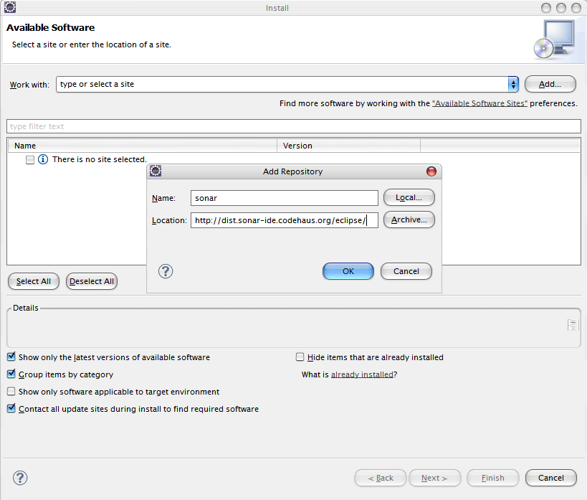

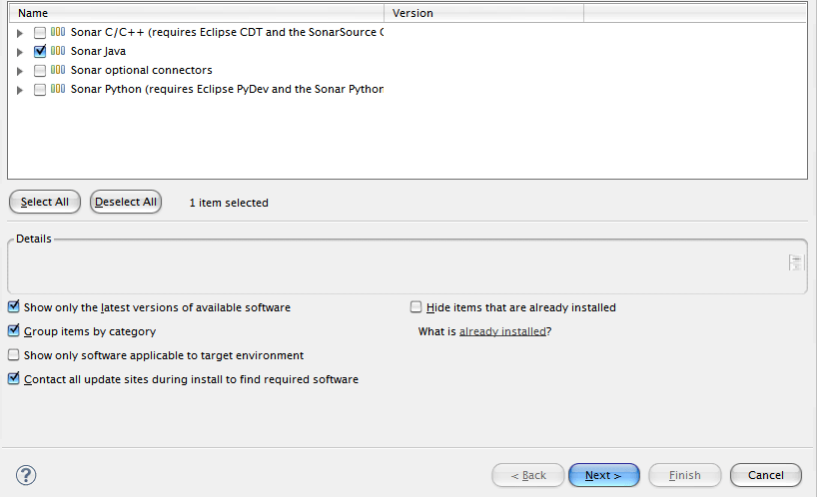

Then select the Sonar Java click next and accept the license details, it will install the Sonar